Invisible fiber optic cable
Specifications of GJI
1、Cross Section（cable）
Sketch map | No. | Parts | Spec | Remark
schematic diagram of cable structure  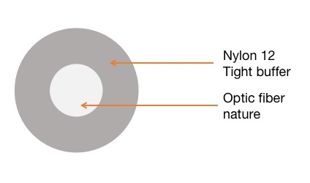 | 1 | tight buffered | Φ0.9mm（±0.05mm） | 1 fiber，Nature
 | 2 | tight buffered sheath material | PA12，nature | ——
 | 3 | weight（kg/km）  （approx.） | 0.7kg | ——
Characteristic of Optical Cable
item | Specifications
Min Bend Radius | 2.5mm
Operation temperature | -5℃~+50℃
Installation temperature | -5℃~+60℃
Storage temperature | -10℃~+60℃
Main mechanical & environmental performance test
Item | test methodme | Test requirements
Tension | Test method: IEC 60794-1-2-E1  Long-term pull: 5N  Short term pull: 10N | The strain of optical fiber is less than 0.3%  and the strain of optical cable is less than  0.3% under the long-term 10N tension.  Fiber strain ≤0.6% at 50N tension;
Crush | Test method :IEC 60794-1-2-E3  Long-term: 300N/100mm  Short term: 1000N/100mm  Times: 3; Interval length: 500mm | In the middle and long term during the test  process loss variation ≤0.1dB;  Loss variation ≤0.1dB after 5 minutes of  short-term test; The optical fiber does not  break and the sheath does not crack.
Peeling force of invisible optical cables
(1) Test method: Using the testing equipment and methods specified in 5.2.2 of TD/T 1258.1-2015;
(2) Peel depth: Peel to the fiber cladding and keep the cladding intact;
(3) Sample length: 500mm;
(4) Test step: The optical cable is fixed to the stripping tool and tension machine through the guide hole on the stripping tool, and then pulled
Tear test with a force machine at a peeling rate of 500mm/min;
Stripping length: 15mm ± 1.5mm; (6) Qualification criteria: When the test result is 10N-25N, it is considered qualified.
3、Optical Characteristics
Type of Fible | G657B3
Attenuation in cable （after cable） | 0.4dB/km @1310nm 0.3dB/km @1550nm

4、Else
Sheath Color | Nature
The length of delivery | According to the customer

Packaging information
Packaging: Fiber optic disc, 2km/reel
Net weight: 1.4kg/reel
Gross weight: 2.1kg/reel
Packing: 6 reels/box
Carton: 500mm * 360mm * 250mm（L*W*H）
Optical fiber characteristics （G.657B3 FIBER）



